AECT Needs Survey, 2000

Theodore W. Frick
Kurt Richter
Minhee Kim
Jessica Chao-I Yang
Abdullah Duvenci

Department of Instructional Systems Technology
School of Education
Indiana University, Bloomington, IN 47405

Abstract
The purpose of this study was to determine the needs of AECT members. A total of 590 individuals completed a web-based survey after receiving an e-mail invitation from AECT. This survey was active between October 30 and November 10, 2000. The survey was categorized into three parts: demographics; publications; and conference. Resulting data was categorized, coded, and compiled. The study yielded five major findings. First, more than half of the respondents are affiliated with higher education. Second, the AECT conference is important to members with or without a trade show. Third, restructuring efforts are incomplete. Fourth, respondents noted communications problems in the organization. Fifth, online services need to be improved. Improved communication within the organization is imperative.

Purpose of the Study
In order to determine needs of AECT members and to identify the association’s strengths and weaknesses, we conducted a survey. We have shared the results of this study with AECT leadership and now summarize the findings for AECT members in order to provide feedback on recent changes in the association, and to help guide decisions about AECT’s future.

Research Questions
Seven research questions were investigated in this study:
- What services does AECT provide well?
- What are the needs of AECT members?
- How satisfied are the members with the quality of AECT publications (TechTrends & ETR&D)?
- How satisfied are the members with the AECT online conference registration service?
- What conference networking opportunities are helpful to members?
- How important is the trade show at the conference to members?
- How satisfied are the members with the decision of restructuring and renaming divisions?

Method

Instrument
We interviewed the current Executive Director of AECT in October, 2000. He shared a list of questions that, after discussion and clarification, were incorporated into the list of questions included in this needs analysis survey. We also used two questions from the 1999 member needs survey to see how members would respond to the same questions. Then we designed the sixteen-question survey which included three demographic questions, five five-point Likert-type scale questions, four multiple choice questions and four open-ended questions.

Participants
AECT maintains a database comprised of members and individuals who subscribe to the periodicals published by AECT. E-mail was sent to 3084 names in the database, of whom 1846 of were members as of November, 2000. The e-mail message invited individuals to complete an online Web survey.

Data Analysis
We ended the survey on November 11, 2000, and prepared both quantitative and qualitative data files for analysis. After examining the data, our team discarded 15 responses from the total number to eliminate multiple responses by individuals; and this yielded 590 member and nonmember unique responses to the survey. We analyzed the quantitative data that were generated by multiple choice and five-point Likert-type scale questions by SPSS. Then we conducted a content analysis with the qualitative data generated by open-ended questions.
The following paragraphs describe how we defined categories for open-ended questions.

Question 4. What does AECT do for you now that you find most beneficial?
In response to the question of what respondents felt was the most beneficial aspect of AECT, respondents’ comments indicated 8 categories of responses. Responses that mentioned written journals, ETR&D, or TechTrends were placed in the category of “Publications”. Typical comments from this category include the following:
- AECT keeps me informed of the most recent findings, studies and research.
- These present broader views and information that I would have trouble finding elsewhere.
- TechTrends
Responses that mentioned any aspect of the national conference were placed in the category of “Conference”. Typical comments from this category include the following:
- The annual conference is the most beneficial part of AECT. As a media/info-tech administrator I always am able to get GREAT information that I can apply when I return home.
- The national conferences were always of value in helping one understand new theories, techniques, and ways in which to use media in the teaching and learning process.
- Annual Conference
Responses that mentioned any aspect of social or professional interaction, whether as part of a conference, presentations, or informal gatherings outside of the conference were placed in a category named “Networking”. Typical comments from this category include the following:
- Networking with colleagues and diversity of programming when it is good.
- Provides a venue for the exchange of knowledge and/or research in our field. Also provides opportunities to network and interact with colleagues.
- Provides contacts with colleagues, old and new, which leads to opportunities to visit and work at institutions outside the U.S.
Responses that mentioned any aspect of professional improvement, current issues, trends, or keeping up with developments were placed in the category entitled “Professional Development.” Typical comments from this category include the following:
- Keep up with latest development in educational technology.
- AECT helps to keep me updated as to what is current in the field.
- Keeps my coworkers up to date on current issues and trends.
Responses that mentioned any aspect of electronic communication through the Internet or the World Wide Web, email or listserv communications were placed in the category entitled “Web Services”. Typical comments from this category include the following:
- The job postings site is most useful.
- The Website is useful. I get most of the information from the AECT Web.
- listserv newsletter.
Responses that included the concept of employment-related issues were placed in the category of “Employment Information.” Typical comments from this category include the following:
- It provides employment leads.
- Job listing (when current).
Responses stating that the respondent does not like some general aspect of AECT were placed in the category entitled “Negative”. Typical comments from this category include the following:
- At this time nothing. Several years ago the journal and conference provided good opportunities for learning.
- I do not currently benefit from AECT.
- I have found nothing of value the last two or three years…the organization has been in transition and cannot function until the transition is complete.
Responses that did not fit into any of the categories that had been established for this question were placed in one category that was entitled “Others”. Each of the responses could possibly make its own category and stand alone in this report, but our research team felt that they should be joined in the “Other” category. Typical comments from this category include the following:
- The membership is diverse, freeing me from the parochial view of one section of the profession; participation in the organization and its governance is encouraged (most national organizations discourage it with red tape); the people are wonderful, supportive and generous with their expertise; the summer leadership institute is excellent.
- Phil Harris, with his staff, and the AECT President and Board of Directors are actively looking for ways to support and encourage the AECT International Student Media Festival. Charles White shares the vision of ISMF that it serves as a natural introduction to AECT for teachers and students interested in the role of media in education.
- TechTrends, copyright issues, new products, how a new technology works in real situations. Ed issues and On-line classes. New topics on Internet usage. Teacher training.

Question 5: Please list the most important thing AECT should be doing for you now that it does not currently do.
In response to question five in which respondents were asked what it was they felt was the most important thing that AECT should be doing that they were not currently doing. Member comments separated into 7 categories of responses. Responses that indicated some kind of need that was associated with the AECT National Conference were placed into the category entitled “Conference”. Typical comments from this category include the following:
- Thought that the lack of exhibits at national conferences was big weakness, but that will be satisfied in Denver, I assume. Organization is now doing, or about to do, most of the things that I think a national professional organization should do.
- I would like to participate in a conference but time, location, and funding are an issue. I would like to see AECT sponsor an online conference or include online conference participation at its f2f conferences.
- Providing a scholarly conference that is respected and has credibility. Provide timely information on topics relevant to our field.
Responses that included a mention of communications, response or lack of response to submitted questions, or a flow of information were put into the category entitled “Communications”. Typical comments from this category include the following:
- Communicate with members better. I sent in my membership months ago, and I’ve started receiving pubs, but I don’t remember receiving any acknowledgment of my membership. I was wondering about it until I started receiving TechTrends.
- Create a clear link of communication between the members and administration so members can become more involved in policy and know what to expect from one conference to the next.
- Provide data/opportunities/support for better communication throughout the year.
Responses that mentioned publications, articles, ETR&D, TechTrends, or journals were placed in the category entitled “Publications”. Typical comments from this category include the following:
- AECT should be continuing to publish a scholarly journal. I have not yet received an issue of ETR&D.
- More publications.
- AECT journals need to improve their quality of articles. Emphasize research-based reviews of educational technology uses in the classroom to help K-12 teachers in implementing technology in the classroom.
Responses that referenced electronic material including websites, listservs, electronic communications, or email were placed in a category entitled “Web Services.” Typical comments from this category include the following:
- Message board or listserv for ongoing member interaction/discussion.
- Provide me with the electronic capability to reach out to my state people and to other colleagues individually and updating me electronically on the state of the organization. Our name says communication and technology or, communication through technology.
- Access to electronic materials e.g. back issues of journals etc.
Responses that included a discussion of the restructuring efforts, organizational efforts, or changes within the AECT were placed in a category entitled “Organizational Restructure.” Typical comments from this category include the following:
- Restructure organization so it can best serve its members (e.g. conference coordination, quality control of its publications, etc.).
- Be more organized and professional.
- Provide a viable organization that combines ‘clout’ with an outlet for academic research.
Responses that indicated a need for development of professional skills or services or for keeping up with trends were placed in a category entitled “Professional Development.” Typical comments from this category include the following:
- Providing a sense that this organization is keeping up with the latest trends in instructional design throughout the year.
- More professional development activities on the regional level.
- Professional Development. I know many people are involved in the leadership and other efforts within AECT, but I don’t know how to get into that ‘inner circle.’ I’ve always felt like an outsider, except for participation in the annual conference.
Responses that noted single instances of a suggestion were sorted into the category entitled “Other”. There was no discernible trend noted in this category, and so they were combined into a single category of suggestions. Typical comments from this category include the following:
- Role of Media Specialists in the changing school environment.
- Continue to seek member involvement in ways like this.
- Uncertain what it could do for me since I’m a bit away from the center of things and haven’t been able to attend a conference for several years. Mainly – just keep information coming.
- I am not aware of services that would be beneficial for me that I am not getting from somewhere else that AECT should provide.

Question 15. How did you first become aware of AECT?
In response to the question of how respondents first became aware of the AECT, comments were sorted into 6 categories of responses. Responses that indicated the individual had first learned about the organization while attending a graduate program or that they had learned about the organization in graduate school were included under the category entitled “In Graduate School.” Typical comments from this category include the following:
- From faculty members during graduate school.
- As a graduate student some 35 years ago….
- Through discussion with faculty in graduate school.
Responses indicating that initial awareness of the AECT organization had come from contacts with professional colleagues and peers were grouped under the category “From Colleagues and Peers.” Typical comments from this category include the following:
- Fellow professionals.
- Recommended by my colleagues.
- My father has been a member for many years, and then when I entered the field, my boss was a member.
Responses from individuals who named a variety of different sources that did not fit easily under existing categories were grouped under the category entitled “From Various Sources.” Typical comments from this category include the following:
- As a beginning professional by attending a regional conference…
- Link from another web site
- In 1980 we hosted the then active Missouri Affiliate in Cape Girardeau MO. I have been a member ever since.
Responses from members who had been a part of the organization for such a long period of time that they couldn’t remember the original exposure to the organization were included under the category entitled “Cannot Remember.” Typical comments from this category include the following:
- Don’t remember…
- Don’t recall…
- …I don’t remember how I became aware of it.
Responses from individuals who first learned of the AECT by means of written publications or journals are organized under the category entitled “From Publications.”
- learn from TechTrends and join by mail.
- In search of publication outlet.
- Via periodics (sic) at University’s library.
Responses from individuals who had first learned of the existence of the AECT while attending an AECT conference are included under the category entitled “At the AECT Conference.” Typical comments from this category include the following:
- Convention in Miami in 1979.
- Through exhibits at the WEMA conference in Wisconsin.
- Really got involved after attending an AECT Region 6 leadership conference in 1981…

Question 16. Please list any other comments that would benefit the AECT leadership in determining future directions.
In response to the invitation asking respondents to list any general comments that would benefit the AECT leadership in determining future directions, respondents’ comments were sorted into 11 general areas. Responses that indicated the AECT needs to focus efforts in the restructuring process were reported under the category entitled “We need to define AECT’s focus.” Typical comments from this category include the following:
- AECT must clearly define its purpose. Direct activities to that purpose. Make its membership services supportive of that purpose.
- AECT needs to decide who its members are and provide opportunities for those members to meet…
- Find your niche, and stick to the knitting. Don’t try to be all things to all people, which the old AECT never learned. Based on what I see in the new division structure, I’m not sure AECT has learned it yet.
Responses that spoke of perceived communication difficulties between the administration of AECT and the membership were grouped under the category entitled “AECT needs to improve communications with the membership.” Typical comments from this category include the following:
- Please have someone available at the telephones at the office. I have tried to reach a person on several occasions and only left messages which were not returned.
- To strengthen AECT membership, I believe AECT should acknowledge its members by sending a membership card…
- There appears to be no way to become involved in the governance and workings of AECT without ‘knowing someone.’ Please promote opportunities for people to become involved in the divisions and councils or in planning the conference.
Responses that indicated problems or solutions to difficulties encountered during attendance at the national conference are grouped under the heading “Conference needs improvement.” Typical comments from this category include the following:
- …improve the organization of the conference. I overheard several people commenting on how unorganized it seemed to be….
- The program needs to be better organized. Denver was a mess with sessions listed in one place, changed in the addendum in another, and shown on the TV monitors in a third….
- …I go to this conference because of its diversity – which was down a good bit this time. Frankly, it has overpriced itself at this point. I would not have attended this conference at this price if I were not involved in governance areas.
Responses that indicate problems or issues that have been apparent within the AECT website are included under the category entitled “Website needs improvement.” Typical comments from this category include the following:
- …keep the WWW site up-to-date (online job listings are great…member directory on-line would be nice).
- Please, please upgrade the website…
- The AECT website needs some dramatic fixing by people who know good graphic and user-interface design and good content editors….
Responses of a broad nature that addressed very specific circumstances and yet were unable to be grouped with other responses formed a category entitled “Miscellaneous.” Typical comments from this category include the following:
- I joined AECT as a graduate student and attended conventions. At the 225 dollar price of Denver, I as a graduate student would never have been in AECT or participated for so many years.
- Get great speakers instead of so many social functions. Cut the exhibits if we can't get enough vendors to make it worthwhile. Confirm all presenters in advance. Cut the costs if possible.
- We MUST have a better process for letting people know if their papers were accepted. We did not find out until we got the program in Denver that one of ours was accepted.
Responses from individuals who expressed a general sense of pleasure with the organization are grouped under the category entitled “Pleased with AECT.” Typical comments from this category include the following:
- I am glad to see that AECT is moving forward again.
- Keep up the great work…
- AECT still has an important role to play in the evolution of technology-based education/training, but perhaps not as an independent society any longer. A merger with AACE or ISPI may be necessary to accomplish what's needed.
Responses from individuals who expressed their appreciation of the fact that AECT conducted this survey to determine the interests of AECT members are grouped in the category entitled “Like the survey.” Typical comments from this category include the following:
- Can't think of anything...this strikes me as a good survey.
- I am pleased to see this survey being done -- it speaks well for the leadership.
Responses from individuals who felt that AECT was not strong enough in getting positive aspects of the AECT program out to the attention of the membership are included in the category entitled “Marketing needs improvement.” Typical comments from this category include the following:
- Some steady, dependable "marketing" will be needed.
- Are you marketing AECT to the school districts? Is AECT represented at library and technology conferences? I do not recall seeing it at those I attend. I hope this helps. Thank you for all the support I have received through AECT.
Responses from individuals who feel that the general leadership of the AECT has diminished over time and that it needs to be asserted are included in the category entitled “Leadership needs improvement.” Typical comments from this category include the following:
- I want AECT to resume a strong leadership position once more in the field of education & communications technology.
- We need to have divisions take a strong leadership role overall and in conference planning specifically.
Responses that mentioned ETR&D, TechTrends, or other journals were grouped under the category entitled “Publications.” Typical comments from this category include the following:
- I think ETR&D should publish more variety and a larger number of articles. For example, it should cover more articles related to network-based learning or Web-based learning.
- I think we should have more publications, and that we should start a research mentoring program. Also, I would like to see a new journal that focuses on on-line learning. That journal could be on-line.

Findings
Of the 590 respondents, 487 (82.5%) respondents reported being current members, 47 (8%) respondents reported not being current members and 56 (9.5%) respondents were not certain whether or not they were members (“Not Sure”). With respect to whether or not the respondent resides in the U.S., 563 (95.4%) respondents stated that they reside in the United States while 27 (4.6%) respondents reported residing outside the U.S.

Question 3: What is your employment setting?

- Approximately two-thirds of the respondents reported Higher Education affiliation, which includes junior/community college or technical institute, college or university campus, or graduate student.

Question 4: What does AECT do for you now that you find most beneficial?
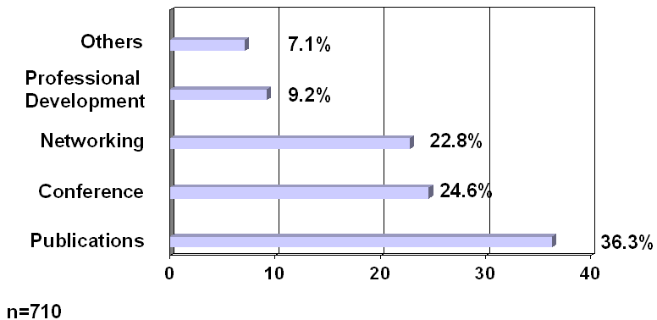

- Respondents identified 4 major areas that were most beneficial. These include Publications, Conferences, Networking, and Professional Development.

Question 5: Please list the most important thing AECT should be doing for you now that it does not currently do.

- Approximately 57% of respondents identified the conference, web services, and efforts at organizational restructuring as the most important things that AECT should be doing but is not doing at the current time.

Question 6: AECT publishes the following journals-Tech Trends and ETR&D. Have you been receiving your publications in a timely manner?

- Of the 580 survey responses, 419 (72.2%) respondents indicated that they have received the publications in a timely manner. It is interesting to note that 31 respondents chose the item" I am not a current AECT member."

Question 7: How satisfied are you with the quality of recent attitudes in Tech Trends?

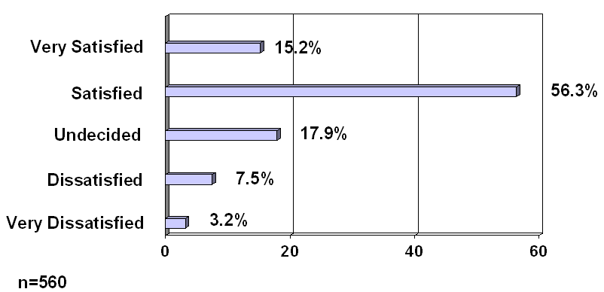

- Of the 560 survey responses, 400 (71.5%) respondents expressed satisfaction with the quality of recent articles in TechTrends. There were 60 respondents (10.7%) expressed some degree of dissatisfaction with the quality of TechTrends.
Question 8: How satisfied are you with the quality of recent attitudes in ETR&D?

- Of the 439 survey responses, 271 (61.7%) respondents expressed satisfaction with the quality of recent articles in ETR&D. There were only 22 respondents (5%) who expressed some degree of dissatisfaction with quality of ETR&D.
- Approximately one-third of the respondents indicated that they were undecided with regard to their satisfaction of qualities in ETR&D.

Question 9: Have you attended an AECT National Conference within the past 3 years?

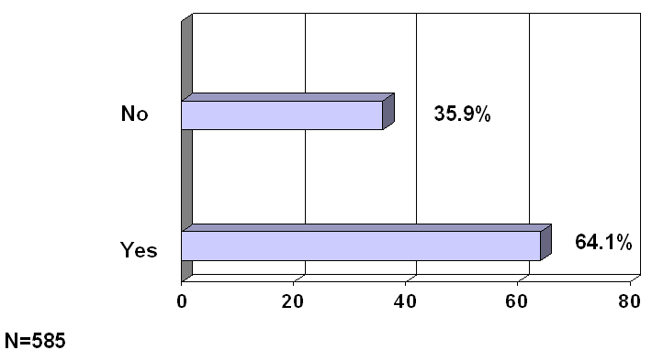

If YES, please indicate which of the following were helpful for meeting people (i.e., networking)?

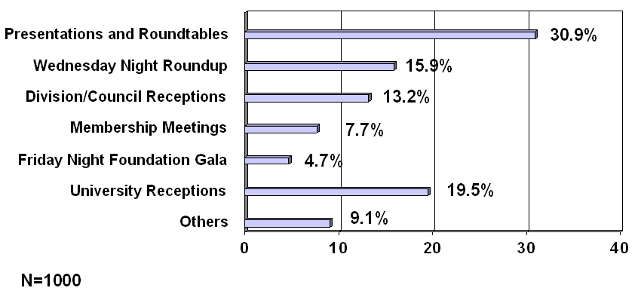

- Respondents addressed the question of what was the most important thing that AECT could do to promote meeting people, the concept of networking with others. Four networking opportunities stood out from the responses, and these included meeting people at presentations and roundtables, the Wednesday night Roundup (AECT Reception at the conference), Division and Council receptions, and University receptions.

Question 10: Were you satisfied with the new online AECT Conference registration service available through the AECT web site?
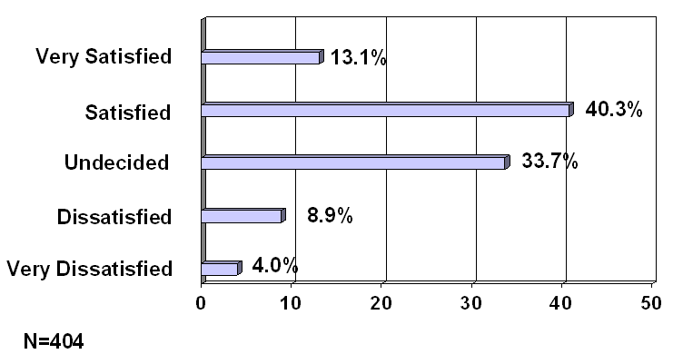

- A total of 216 (53.4%) respondents expressed some degree of satisfaction with the online registration.
- Note that almost a third of respondents were undecided with respect to their satisfaction with the online registration service.

Question 11: AECT changed its conference date from early February to late October, in order to meet concurrently with the National School Board Association, so that AECT members could visit the large trade show. Do you agree with this decision?
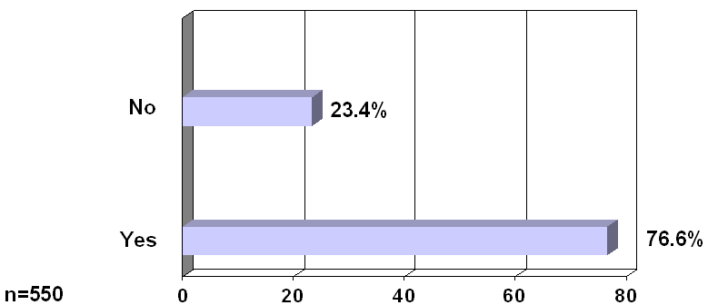

- There was a ratio of approximately three to one among respondents who agreed with the decision to change the date of the AECT conference so that it met concurrently with the National School Board Association (NSBA).

Question 12: How do you feel about the trade show at the AECT Conference?
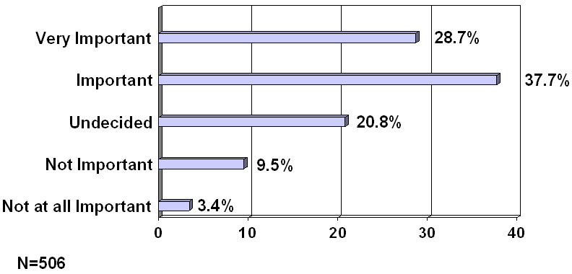

- 336 (56.4 %) respondents believed that the trade show is important or very important.

Question 13: Do you know that AECT has recently established a toll-free number?

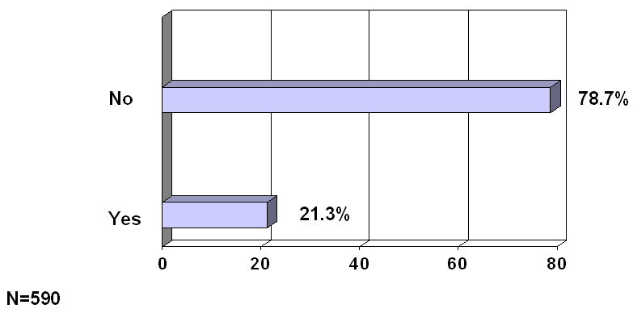

- More than three-fourths of respondents were not aware that the AECT had obtained a toll-free number.

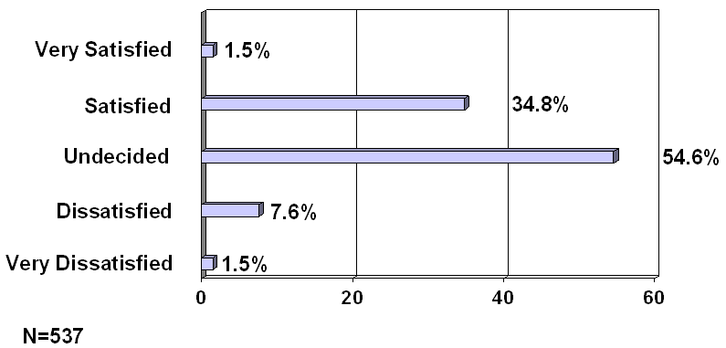
Question 14: AECT made the decision in 1999 to restructure and rename divisions and councils. How do you feel about that?

- A total of 195 (36.3%) respondents expressed satisfaction with the restructuring efforts. This included 187 (34.8%) respondents who were satisfied and 8 (1.5%) respondents who were very satisfied. It is important to note that a greater percentage of respondents expressed some degree of satisfaction with the restructuring (36.3%) than those who expressed some degree of dissatisfaction with the restructuring efforts (9.1%). A slight majority of respondents expressed neither satisfaction nor dissatisfaction with the restructuring efforts.

Question 15: How did you first become aware of AECT?

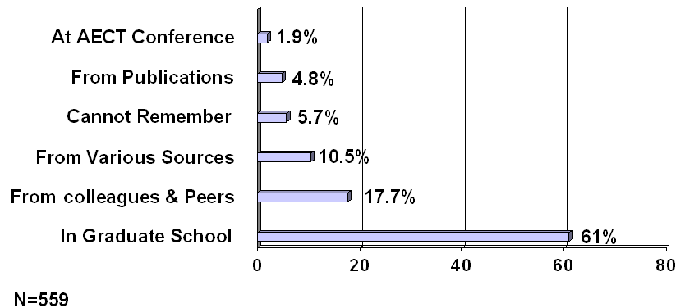

- The greatest percentage (61%) learned of the organization from their graduate school experience, and 116 of those respondents heard of AECT directly through a graduate school professor.

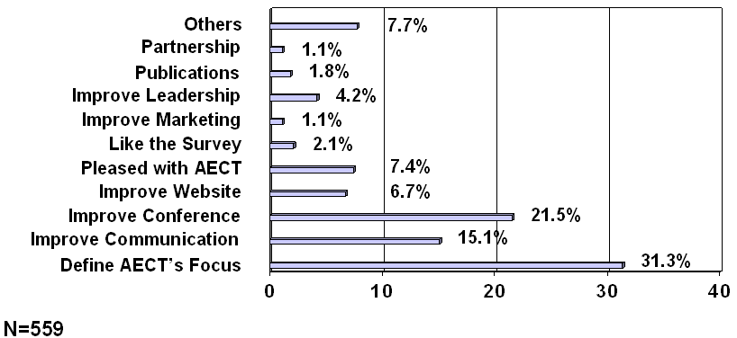
Question 16: Please list any other comments that would benefit the AECT leadership in determining future directions.

- Respondents were given the opportunity at the end of the survey to express themselves on any topic that they felt was beneficial to the organization. The largest group (31%) felt that defining AECT’s focus is mission critical.
- 15% of respondents felt that AECT needs to improve communication with its members and 22% of respondents felt that improvement is needed in the AECT national conference.

Discussion

Higher Education
It is important to note the fact that more than half of the respondents are affiliated with higher education at the community college and university level. Of the K-12 respondents to this survey, they often found that there was little of value for them at the trade show in conjunction with the conference. As AECT continues the restructuring process, it will be important to determine the role of K-12 members in the organization. If the association wishes to include the K-12 members in a significant manner, they must examine methods to do so. It is clear that the organizational emphasis is currently on providing services to the majority of their membership, which is involved with Higher Education as evidenced by this survey.
More than half of the membership of AECT joined because of an introduction that occurred during their work in graduate school. Of this, about a third mentioned that they had first heard of the AECT through their professors. AECT’s efforts at getting out the word in the graduate schools that teach courses having a technology base seems to pay off in increased membership. Anything that AECT can do, such as giving breaks to graduate students for conference participation or membership, is likely to realize a benefit for the organization as a whole later on.

Conference
AECT members state that they found the conference to be the second greatest benefit of membership. The conference was also stated to be the second highest service that AECT offered requiring improvement. Members were vocal in offering remedies for the conference, and AECT administration would be well advised to examine these comments thoroughly.

Communication
An issue that emerges clearly across all of the survey questions is the issue of communication between the administration of AECT and the membership of the organization.
The issue that is mentioned most often is the frustration of individuals who are unable to receive a response to queries for information. A good example of this is the fact that 9.5% of the individuals to whom this survey was sent were uncertain of their membership status. AECT uses time and resources to contact the individuals who are a part of their database, and it is strongly suggested that they clarify this situation at the earliest opportunity.
Most people were pleased with the online registration services that were available for the conference. There were some important exceptions noted. Of the respondents who mentioned that a purchase order was needed so that their sponsors could pay for registration, it seems that such a service was not offered. Additionally, concern was expressed about the security of the web site and people were uncertain that their personal information would be kept in confidence. AECT might consider explaining the security issue in future registration offerings to address these concerns.
A final issue exists with respect to the online services area. Concern was expressed that the AECT should be a leader in the field of website technology, and many felt that the current website was lacking in information, design, and services. It was mentioned that AECT should spend resources to see that the website would address these issues in a state of the art manner so as to present a model website to the world.
Most people did not know that the AECT has a toll free number. If the Association wants this number to be highly visible, they must consider placement of the number in a visible manner through all of the ways that they contact the membership. This would include the website, email communications, journals, and personal communications.

Publications
AECT publishes two journals, TechTrends and ETR&D. The first is available with membership and the second only by special subscription. This must be thoroughly explained to all who receive these publications. There was some confusion about these journals at time of this study. Further, publication and delivery of the journals in a timely manner should be a priority to the organization.

Leadership
The task of restructuring AECT to better meet the needs of the membership is not complete, and efforts in this area need to continue. It is essential that restructuring efforts be communicated to the membership of AECT and that the membership must become more actively involved at more stages in the restructuring. If it is at all possible, AECT administration should initiate a quality control action aimed at assuring members that their needs are being addressed.

References
Association for Educational Communications and Technology Renewal Implementation Task Force. (1999). AECT renewal implementation subcommittee reports. Proceedings of the 1999 Annual Convention of the Association for Educational Communications and Technology.
Branon, R., Graham, D., Kim, J., & Pyke, J. (1999). The association for educational communications and technology (AECT): Member needs analysis. Unpublished Needs Analysis Research Report, Indiana University Bloomington, Bloomington.
Cohen, J. (1960). A coefficient of agreement for nominal scales. Educational and Psychological Measurement (20), 37-46.
Heinich, R., Molenda, M., Russell, J., & Smaldino, S. (1999). Looking ahead. In Instructional media and technology for learning (6th edition) (p. 411). Columbus: Merrill.
Molenda, M., & Cambre, M. (1977). 1976 member opinion survey. Audiovisual Instruction, 22, (pp.46-49).
Saettler, P. (1990). The evolution of American educational technology (pp. 502-506). Englewood, Colorado.
Silber, K. H. (1978). Problems and needed directions in the profession of educational technology. Educational Communication and Technology Journal, 26, (p.184).

